**Asgn B10**

**ISO Boot Image**

Screenshots:

**Step 1: Getting Started**

Run your installed WinISO software. Open an existing ISO file, and then check to see if this ISO file is not booted.

[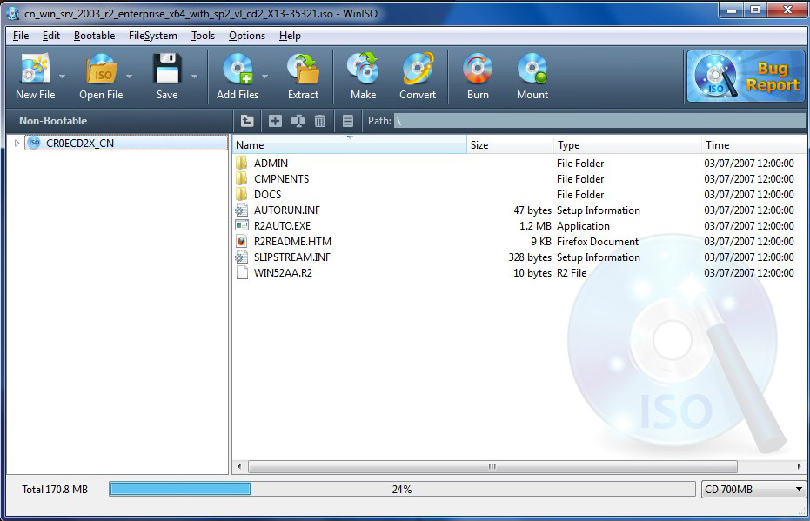](http://www.winiso.com/image/main.jpg)

**Step 2: Choose the bootable option**

Click "bootable" on the toolbar. If actions are limited, you need to insert an existing boot information into the file.

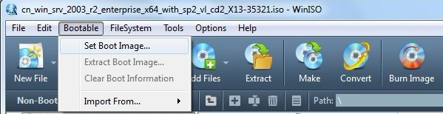

**Step 3: Set boot information**

Press the "Set Boot Image", a dialogue box should appear on your screen immediately afterward. Select your existing boot information, then click "Open".

[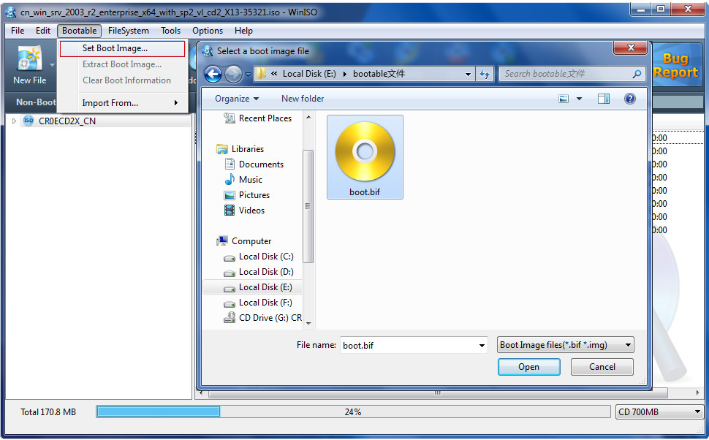](http://www.winiso.com/image/iso-to-dvd02.jpg)

**Step 4: Save**

Click "Save" to save to complete.

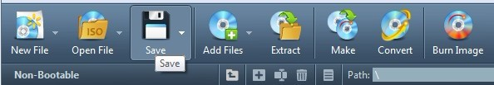

After seeing this text, make bootable ISO image file was completed successfully, and you have created a bootable ISO file. If desired, this ISO file can be burned to get a bootable CD/DVD/Blu-ray Disc or an USB Flash drive